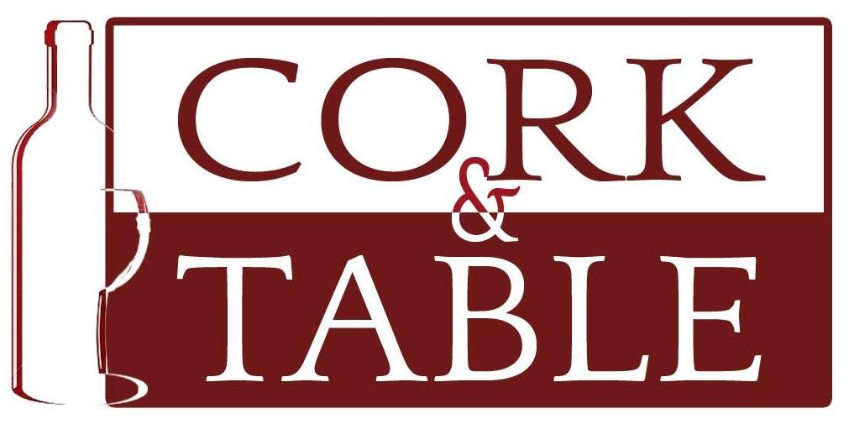Restaurant Week Menu
Three Course Dinner - $51.26 With Two Wine Pairings $72.26
Four Course Dinner - $59.26 With Three Wine Pairings $88.26
CRAB and CORN CHOWDER smoked bacon, cream sherry gf

or

PUREE of BUTTERNUT SQUASH white truffle oil, garam masala gf, veg
2023 Antech Cellars Sparkling Blanquette de Limoux | France
-------------

BLUE CHEESE & BACON SALAD gf
organic greens, marinated grape tomatoes, country dijon dressing
or
SMOKED SALMON SALAD gf
cucumbers, tomatoes, goat cheese, tarragon caper dressing

2023 Viña Temprana ”Old Vines” Garnacha, Campo de Borja, Spain
-------------
SAUTEED ATLANTIC SEA SCALLOPS gf
Jasmine rice pilaf, saffron aioli , winter vegetables

2023 Averaen Cellars Pinot Noir, Willamette Valley, Oregon
or
GRASS- FED BEEF TENDERLOIN MEDALLIONS with GARLIC SHRIMP gf
Yukon Gold puree, port reduction, winter vegetables
2023 Viña las Perdices Cabernet Sauvignon, Mendoza, Argentina
Vegetarian/Vegan entree and dessert options are available upon request.
-------------
DARK CHOCOLATE POT de CREME Dark chocolate pearls, strawberries gfo, veg | or CLASSIC CHEESECAKE  Fresh berries, raspberry sauce veg

Cork & Table is proud to support The Fredericksburg Regional Food Bank in its efforts to Feed People and Fight Food Insecurity in our community.

